Machine Learning Algorithms in AI Economic Agent

In our AI Economic Agent we will use multiple Machine Learning algorithms where each algorithm has its own role.
Our project typically uses two categories of ML Algorithms.

A) Forecasting Algorithms (Time Series Models)
B) Pattern-Learning Algorithms (Structural Learning)

Forecasting Algorithms:
These models are using for Future Predictions and Trend Forecasting.

1) ARIMA / SARIMA
- Used for Linear Relationships
- It works good for Short-term forecasting
- Handles Seasonal data

2) PROPHET (Meta’s Forecasting Model)
- Handles missing data
- It predicts abrupt changes effectively
- Simple tuning

3) LSTM / GRU (Deep Learning)
- It Learns Long-Term patterns
- It captures Non-Linear Relationships
- Strong for Financial Forecasting

4) XGBoost / Random Forest Regressor
- It Detects Non-Linear Patterns
- Useful for multi-variable forecasting in economic data
- They also provide feature importance (economic insights)

Pattern-Learning Algorithms (Structural Learning)
These models learn the data behavior, patterns, trend shifts, and volatility

1) Clustering (K-Means, DBSCAN)
- Identifies
  - Deficit worsening phases
  - Stable phases
  - Crisis periods

2) Anomaly Detection (Isolation Forest)
- Sudden Crash
- Unusual Spikes
- Outliers

Why we use Multiple ML Algorithms
AI Economic Agent will be Multi-Model

Reason:
In Economic Data,
- Some Patterns are Linear → ARIMA
- Some Non-Linear → LSTM / XGBoost
- Some Seasonal → SARIMA
- Some Random Shocks → Prophet
- Sometime relationship are not stable → Use Ensemble

For the best results:
→ Hybrid + Ensemble Model
It combines:
- ARIMA Forecast
- LSTM Forecast
- Prophet Forecast
- XGBoost Trend Rist Score

Final Result = Average + Weighted output

How AI Economic Agent trains these ML Models:

STEP 1 - Historical Current Account Data Input
Load CSV
System Loads:
- Dates
- Values
- Sub-components

STEP 2 - Feature Engineering
System Automatically Generate:
- Month
- Quarter
- YoY Change
- MoM Change
- Rolling Averages
- Volatility Index
- Seasonal Index

STEP 3 – Multiple Algorithms Training
Each Model do its own work

Model | Role
ARIMA | simple linear forecast
Prophet | seasonal + trend
LSTM | deep non-linear patterns
XGBoost | multi-feature regression
Isolation Forest | anomalies detection

STEP 4 - Ensemble Output (Final Prediction)
AI Economic Agent combines all models output.

Example:
- ARIMA → -2.1B
- Prophet → -2.3B
- LSTM → -2.0B
- XGBoost → -2.2B

Final forecast: ≈ -2.15B.

STEP 5 – Explainability:
The AI Economic Agent will tell the user:
- why the prediction occurred
- which factor had the highest weight
- import/export mismatch effects
- seasonal pattern
- political/economic shocks

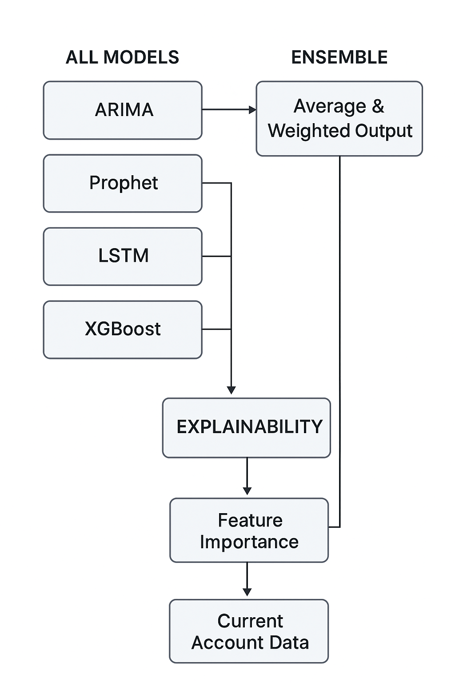
Model Pipeline Diagram & Training Flowchart
Architecture Visualization:

